|  |  |
| --- | --- |
|  | Chef node removal |

|  |  |  |
| --- | --- | --- |
|  | Document Reference: | None |
|  | Current Version: | 1.0 |
|  | Version Date: | 10/12/2018 |
|  | Status | Final |
|  | Author: | Sebastien Chartrand |
|  |

Table of Contents

1 Document Control 1

1.1 Document Control/Change History 1

2 Delete node from chef automate 1

3 Delete node from chef server 1

# Document Control

## Document Control/Change History

|  |  |  |  |
| --- | --- | --- | --- |
| **Version** | **Date** | **Comment** | **Editor** |
| 0.1 | 2018-12-19 | Draft | Sebastien Chartrand |
| 1.0 | 2018-12-19 | Final | Sebastien Chartrand |

# Delete node from chef automate server

1. Log on to the chef automate web interface. Click on *Client Runs,* then the *All* ***Chef servers.*** Make sure that all chef servers is checked.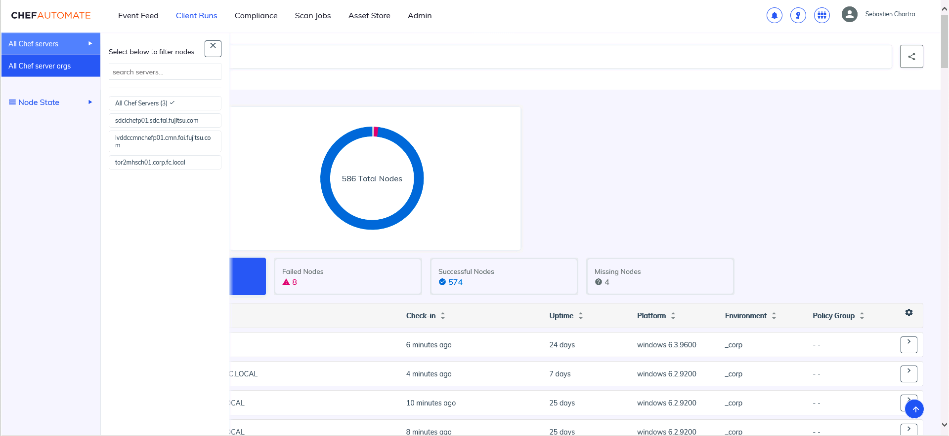
2. Click in the search bar, select node name.

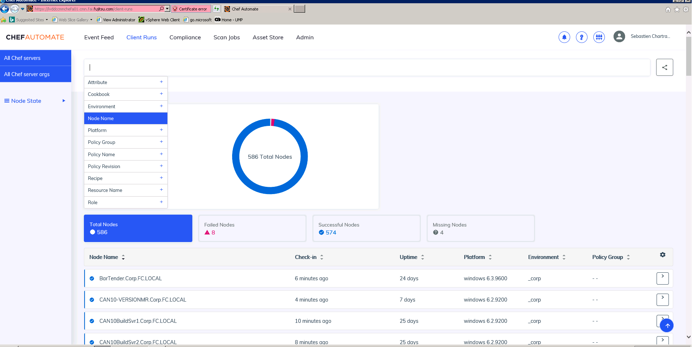

1. Enter the name of node you want to delete



1. If no match is found, update the TFS task with a comment and mark it has completed.

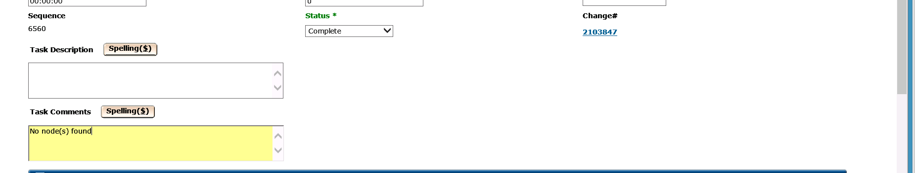

It is also possible to search only part of the name. This useful if you got multiple servers to delete. For example, if you need to delete web01 to web05, you can simply search for the keyword web.

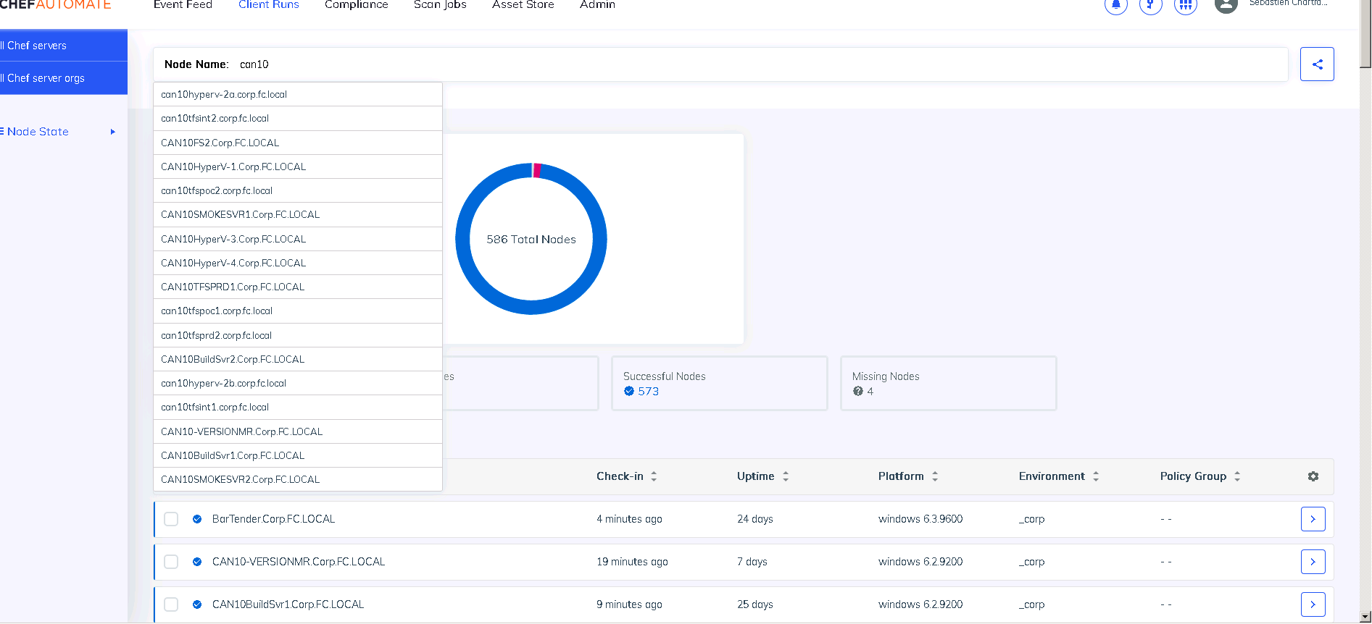

If match is found, simply check the checkbox and then the delete node button.

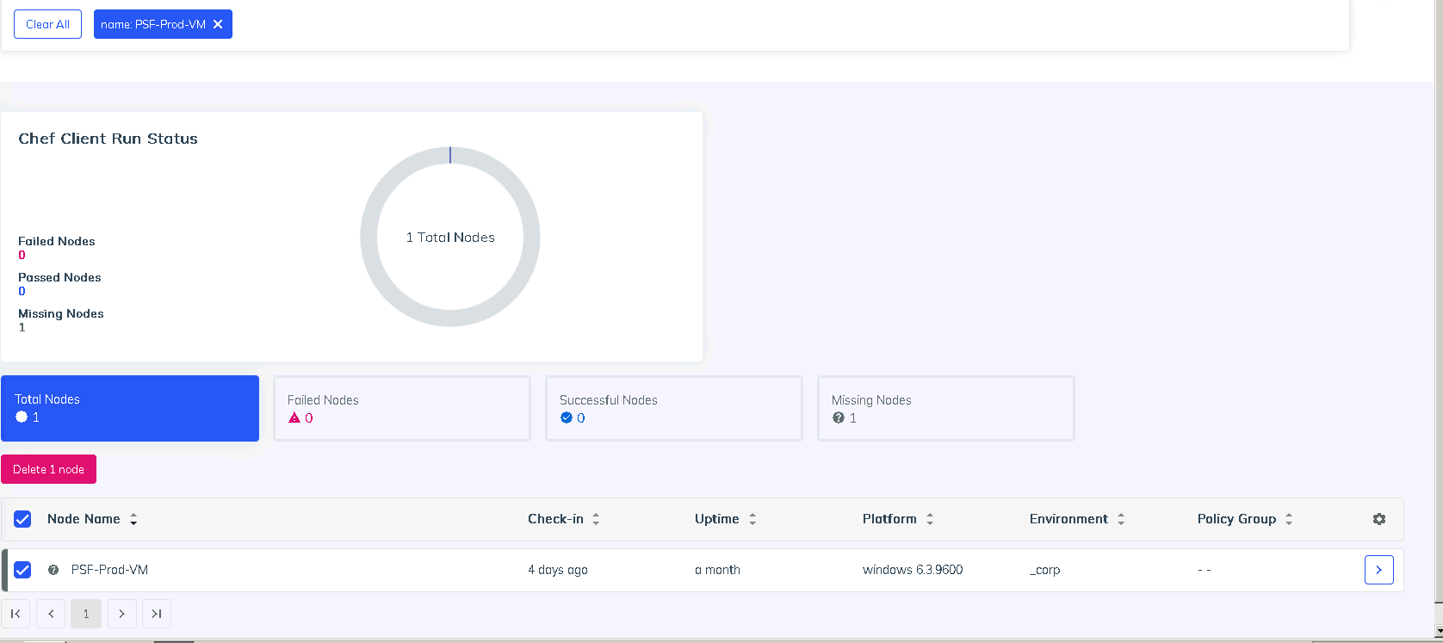

If for some reason you cannot delete it from the web interface, you can click on the node to get more details. Look for the NodeID.

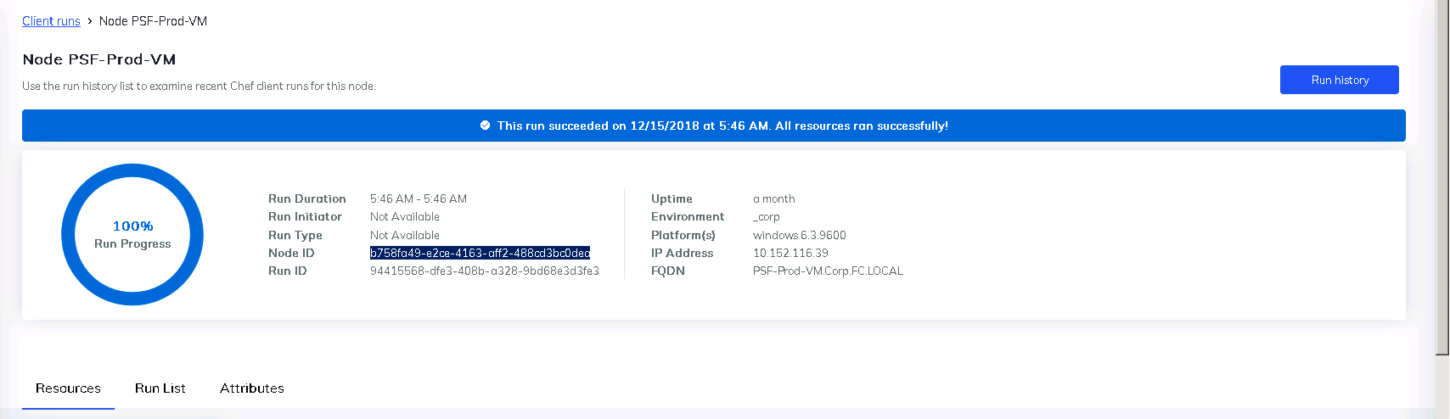

From the command line, on the automation server, you can then do a chef-automate infrastructure node-delete NodeID

chef-automate infrastructure node-delete b758fa49-e2ce-4163-aff2-488cd3bc0dea

Node successfully deleted

# Delete node from chef server

We also need to delete the node from the chef server. For this step, make sure you have downloaded your starter kit from all 3 chef-servers (TDC, SDC, CMN). You can refer to previous documentation or this link <https://github.com/aink99/chef_doc#starter-kit>.

On the chef workstation lvcmncmnchefwkp01, enter the proper chef-repo and do a knife node list|grep -i NodetoDelete

chef-repo-sdc]$ knife node list|grep -i PSF-Prod-VM

PSF-Prod-VM

Then delete the node

knife node delete PSF-Prod-VM

and client

knife client delete PSF-Prod-VM

If you wonder what is the difference between a node and client, A Node has the list of recipes to be run, and a Client has the permission level to access chef-server.